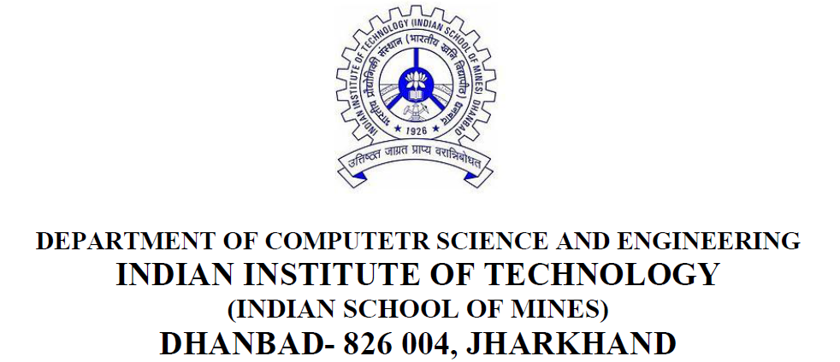

**Wireless & Mobile Computing Lab Manual**

**(Subject Code : CSC52206)**

***Submitted by -***

***Name : Nitish Bhattacharjee***

**(M.Tech, First Year, Second Semester, Session 2017-2020)**

**Admission No. : 17KT000134**